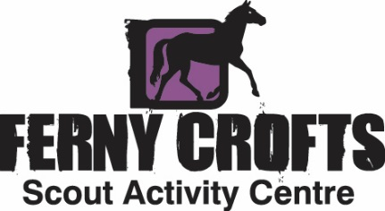

**4.6 – PROCEDURE ON BREAKAGES, LOSS AND DAMAGE CAUSED BY GUESTS**

Ferny Crofts Terms and Conditions (General Rules, Point 15) refer to damage and or loss to Ferny Crofts equipment, property or the environment/trees, and that the group may be charged for any malicious damages caused. The purpose of this document is to set out exactly what is meant by this.

Note that this procedure does not apply to damage or breakages caused by normal use, or reasonable wear and tear.

**Any damage caused by inappropriate use will incur the following charge:**

* The following items will have a standard charge of £10**:**
  + Lost or non-returned keys
  + Self-Led Activities equipment (Table Tennis Racquets, Golf Clubs, Games Box contents etc)
* For any larger item, an Admin fee of £25 plus the actual cost (inclusive of VAT) of the repair or replacement.

All charges will be against the lead contact on the group’s booking, even if the loss or damage is caused by someone else in their group. All charges are at the discretion of the Operations or Activity Manager.

**Damage to Trees**

All trees at Ferny Crofts are subject to a Tree Preservation Order. If group members are found to be causing damage to the trees on site then the group may be asked to send that person home, or the whole group may be asked to leave by the Duty Manager. If deemed necessary, the group may be banned from making future bookings for a number of years to be defined by the Duty Manager on a case-by-case basis in accordance with the level of damage caused.

If any costs are incurred for making damage safe, or fines received from the Forestry Commission or New Forest National Park Authority, these costs will be passed on to the lead contact of the booking.